**Salesforce Data Cloud Functionalities**

**Data Cloud Streaming Ingestion API**

**Process Document**

|  |  |
| --- | --- |
|  |  |
|  |  |

**Overview:**

Ingestion API is a REST API and offers two interaction patterns: bulk and streaming.

The streaming pattern accepts incremental updates to a dataset as those changes are captured, while the bulk pattern accepts CSV files in cases where data syncs occur periodically.

The same data stream can accept data from the streaming and the bulk interaction.

**Steps to implement ingestion API through postman:**

1. **Create connected App on salesforce for authentication purpose:**

* A connected app needs to be configured for a developer to send data into Data Cloud using Ingestion API.
* A connected app is a framework that enables an external application to integrate with Salesforce using APIs and standard protocols, such as SAML, OAuth, and OpenID Connect.
* Connected apps use these protocols to authenticate, authorize, and provide single sign-on (SSO) for external apps.

1. Go to Set up.
2. Search for App manager
3. Click on New Connected App
4. Give details like:

Connected App Name, Contact Email

1. Click on check box for Enable oauth settings
2. Give callback url as https://login.salesforce.com/
3. Select required oauth scopes like:

* Manage user data via APIs (api)
* Manage user data via Web browsers (web)
* Perform requests at any time (refresh_token, offline_access)
* Manage Data Cloud Ingestion API data (cdp_ingest_api)
* Manage Data Cloud profile data (cdp_profile_api)
* Perform ANSI SQL queries on Data Cloud data (cdp_query_api)

1. Click Save
2. Open Manage Connected Apps in the Setup and search further for the created connected app.
3. Click on Edit.
4. Under OAuth policies select “ All users may self-authorize” for permitted users and select “Relax IP restrictions” for IP relaxation.

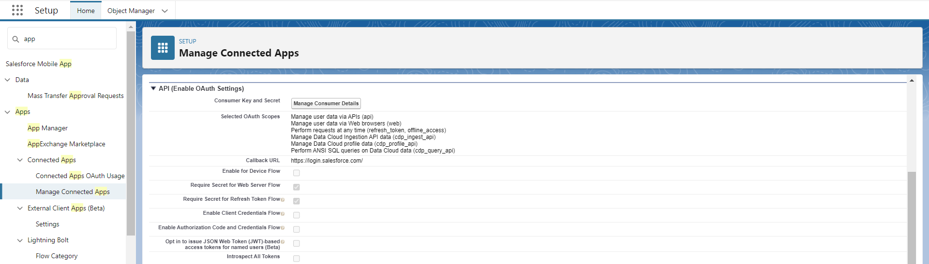

1. **Create Ingestion API connector on Data Cloud:**
2. Go to Data Cloud Set Up
3. Click on Ingestion API
4. Click New
5. Give Connector Name
6. Upload JSON Schema to define the structure of data.(PFA sample **JSON file** in **yaml** format)



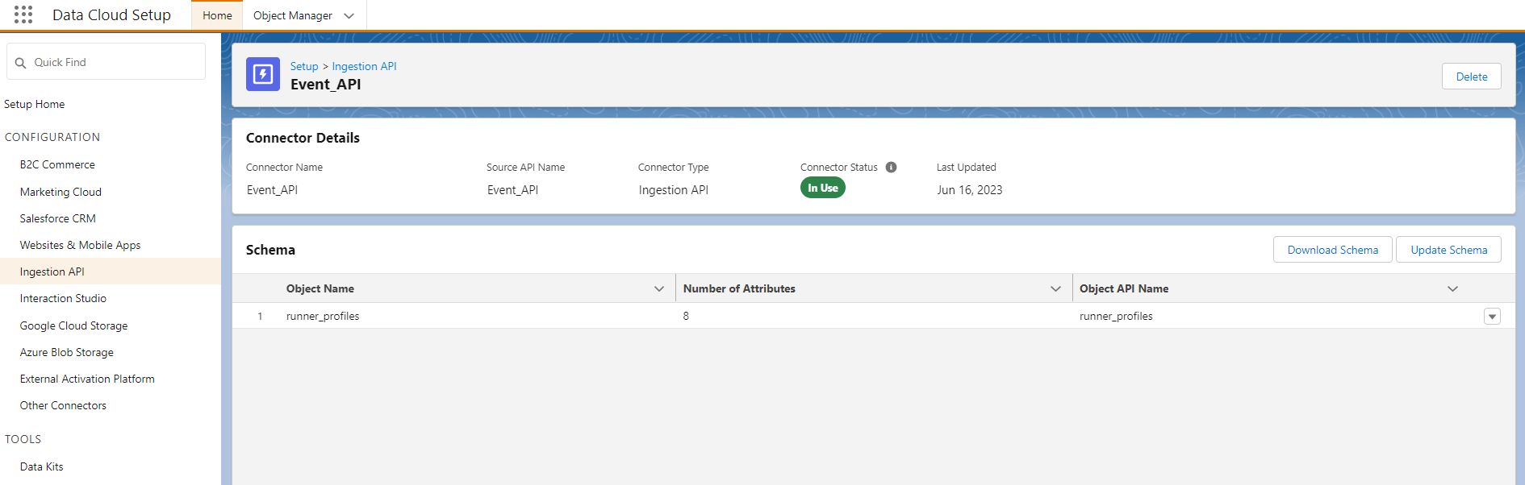

1. **Create Data Stream using Ingestion API connector**
2. Go to Data Streams Tab on Data cloud
3. Click new
4. Connect using Ingestion API connector
5. Use the configured connector
6. Give required details like Data Stream Name, Type of Data, Primary Key etc.
7. **Pushing Data from Postman using Streaming Ingestion API:**
8. To Set up the oauth 2.0 flow for getting access bearer token.
9. Create new collection on Postman
10. Under the collection Pass a post request to generate bearer access token using username password authorization.

* **Get Access Token:**

POST <https://login.salesforce.com/services/oauth2/token>

Under Params,

Give Key and value as follows:

* Username = Salesforce login username
* password = combination of login password and security token(obtained from settings on data cloud under reset my security token)
* grant_type=password
* client_id= Consumer key (obtained from manage consumer details on connected app)
* client_secret= Consumer secret (obtained from manage consumer details on connected app)

Click on Send.

Response will return Access token and instance URL

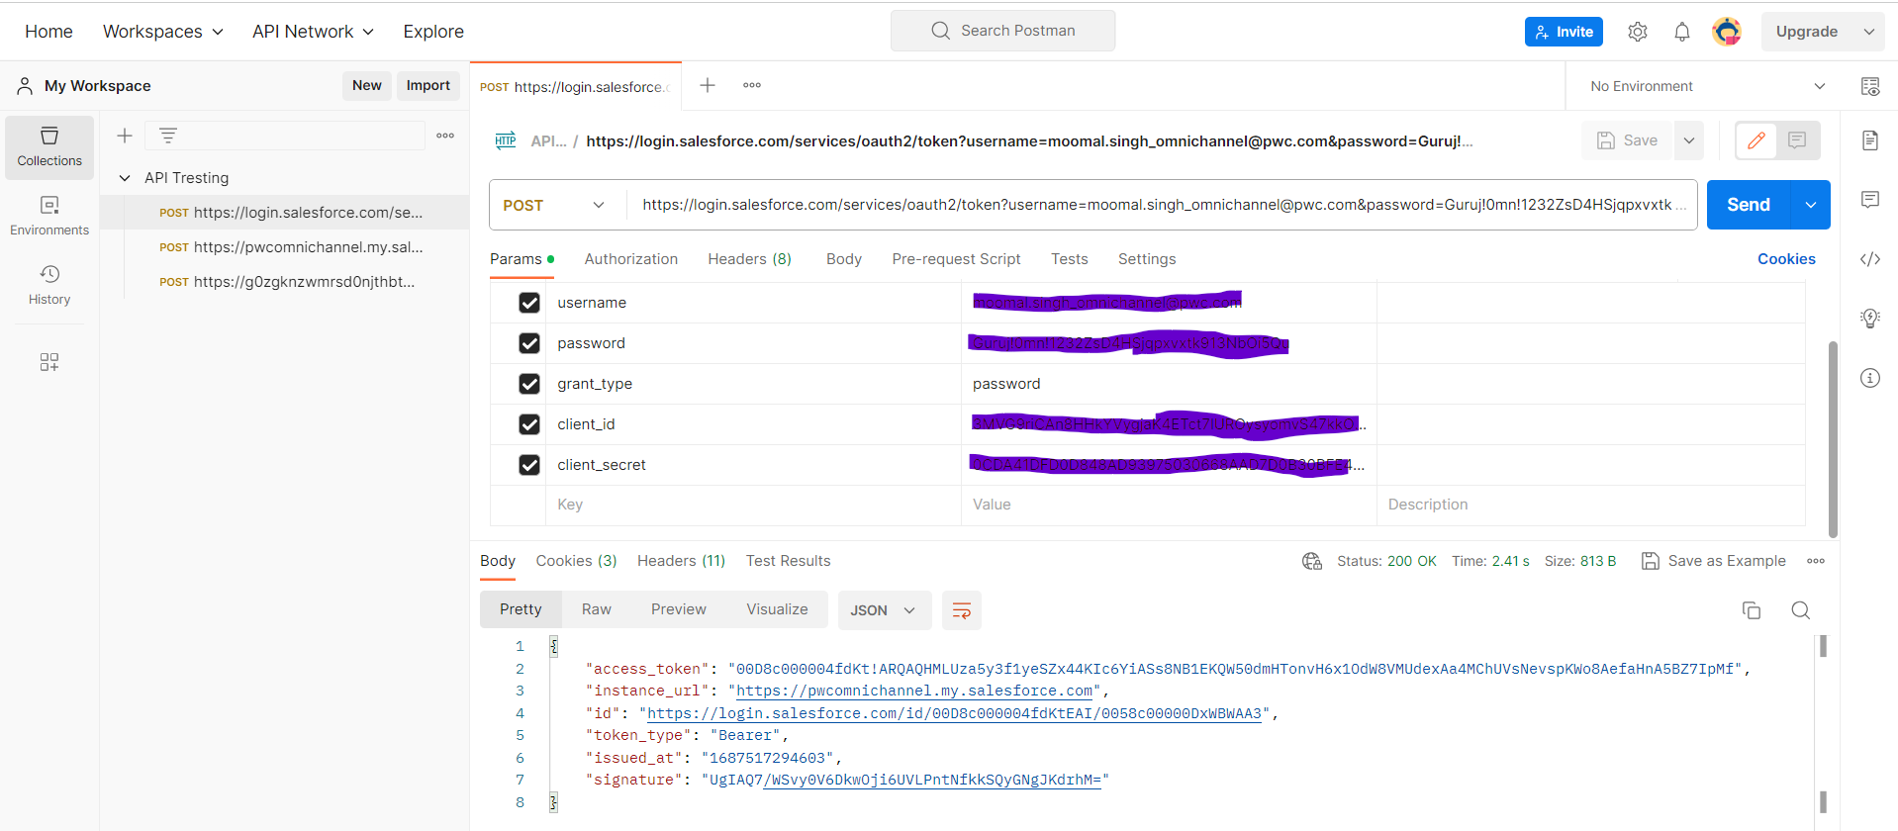

* **Exchange access token with Data Cloud:**

Run following Post request on Postman:

POST <Instance URL>/services/a360/token

Content-Type : x-www-form-urlencoded

grant_type=urn:salesforce:grant-type:external:cdp

&subject_token=<CORE ACCESS TOKEN>

&subject_token_type=urn:ietf:params:oauth:token-type:access_token

Where,

* CORE ACCESS TOKEN is access token obtained from previous request and Instance URL obtained from previous request.
* (Content-Type, grant_type etc, will come under Params)
* Response will now return bearer access token for sending data through authorization request and Instance URL returned here will be used as Data cloud instance endpoint for sending data in next Post request.

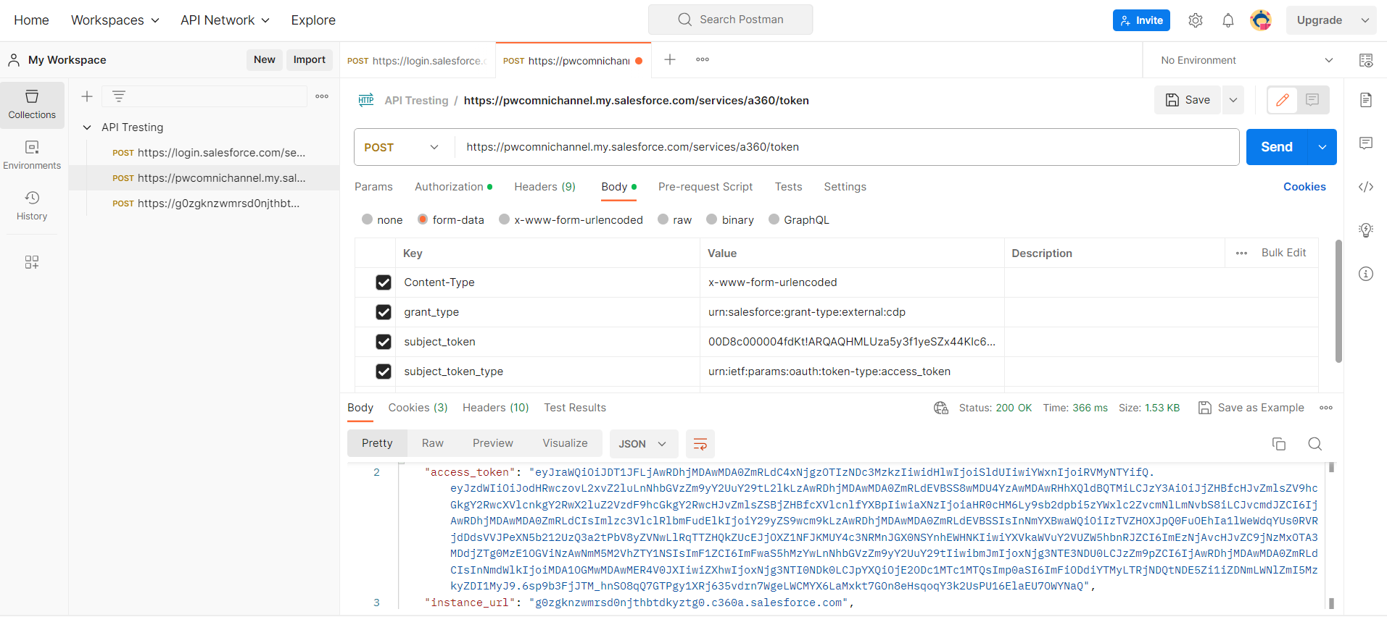

* **Run post request to send data to Data cloud using Ingestion API:**

POST https://{{dne_cdpOffcoreUrl}}/api/v1/ingest/sources/{name}/{object-name}

Eg: <https://g0zgknzwmrsd0njthbtdkyztg0.c360a.salesforce.com/api/v1/ingest/sources/Event_API/runner_profiles>

Where,

* {{dne_cdpOffcoreUrl}} is CDP URL returned as instance URL in the response from Post request for Exchanging the tokens.
* {name} is ingestion API connector name create don data cloud
* {object-name} is object name into which data needs to be pushed in CDP.
* Make sure to enter access code as oauth bearer token under Authorization header obtained from previous Post request.
* Under Body header give the values of the data to be pushed in JSON format.

**NOTE:** records are pushed to CDP within 5 minutes.

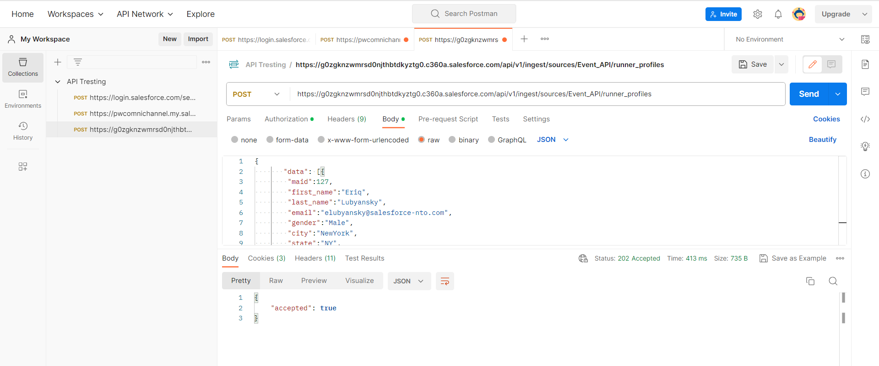

**Reference Links:**

<https://developer.salesforce.com/docs/atlas.en-us.c360a_api.meta/c360a_api/c360a_getting_started_with_cdp.htm>

<https://help.salesforce.com/s/articleView?id=sf.remoteaccess_oauth_username_password_flow.htm&type=5>

<https://developer.salesforce.com/docs/atlas.en-us.c360a_api.meta/c360a_api/c360a_api_insert_records.htm>

<https://hevodata.com/learn/salesforce-rest-api-postman/>